Institute of Cost and Management Accountants of Pakistan
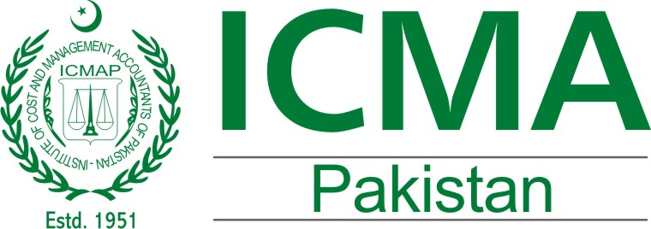
Research & Publications Directorate

Survey on Draft Companies Act, 2015

Objective:The Securities and Exchange Commission of Pakistan (SECP) has prepared a Draft Companies Act 2015 to repeal the existing Companies Ordinance 1984. The SECP has sought public comments and started consultative process with the stakeholders to have feedback on the draft law and incorporate the same with a view to incorporate best practices to ensure better corporate governance. In order to seek opinion of the professionals on the draft law, the Institute’s Research and Publications Directorate has decided to initiate a survey to assess the significance of amendments with special reference to the CMA profession and members.

Sr. | Questions | Options
1 | Existing Companies Ordinance need to be amended to ensure better transparency and corporate governance? | □ Strongly Agree □ Agree  □ Somehow Agree □ Don’t Agree
2 | There is a need to simplify the law in the shape of new law | □ Strongly Agree □ Agree  □ Somehow Agree □ Don’t Agree
3 | The rights of Rs.3 million and above for audit of private limited company to only one profession restricts promotion and limit choices of audit in the country. | □ Yes □ No
4 | The CMAs shall also be eligible to perform audits of companies under the new draft law (section 248 of the proposed repealed law) | □ Yes □ No
5 | Section 252 of Companies Draft Law shall be amended to only allow CMAs to perform Cost Audit. | □ Yes □ No
6 | The companies shall be encouraged to establish Management Accounting/Cost Accounting Department / Section for management reporting, internal efficiency and regulatory accounting. | □ Yes □ No
7 | The establishment of management accounting department be made mandatory in manufacturing concerns with Chief Management Reporting Officer (CMRO) positions with eligibility criteria as CMAs | □ Yes □ No
8 | Have you sent formal comments to SECP? | □ Yes □ No

Any other Comments / Feedback

We thank you for your time and energy spent to fill-in the questionnaire.

Kindly email filled-in questionnaire to: rp@icmap.com.pk latest by Saturday, 30th January 2016

------------------------------ End ------------------------------

